# User Guide for BEAC Model

#### Quick Guide

1. Read the announcement   
   <https://www.gov.uk/government/publications/life-cycle-impacts-of-biomass-electricity-in-2020> about the BEAC report and model.
2. Download the full report <https://www.gov.uk/government/uploads/system/uploads/attachment_data/file/332946/life_cycle_impacts_of_biomass_electricity_in_2020.pdf> DECC URN 14D/243 and read these sections:
   * Exec Summary
   * Definitions
   * Introduction
3. Download the model (Excel spreadsheet)   
   <https://www.gov.uk/government/uploads/system/uploads/attachment_data/file/332948/beac_1.xlsm> and check that it is compatible with your computer: it is written using Excel 2010. It will run on 1280x800 screens but is better on larger displays.
4. Open the model and read these tabs. If you are reading the model for the first time, read the tabs in this order.  
   * “Welcome” tab: check that it says “**Welcome to DECC's Prototype BEAC (Biomass Emissions and Counterfactual) Model**”

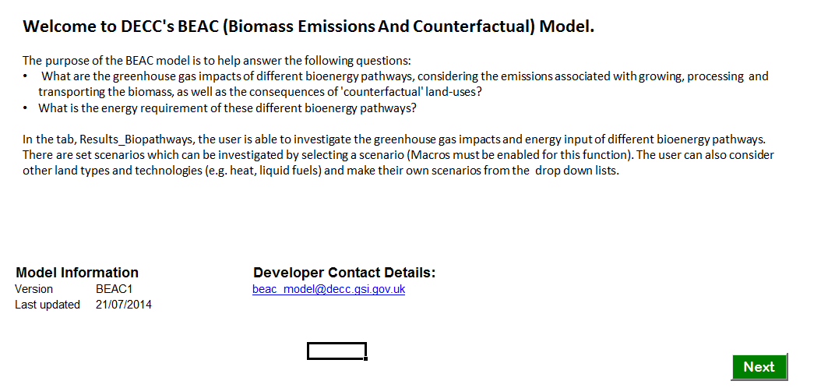

* + In the bottom left of this screen, you will see section called “Model Version Information”. Check that you are reading a called “**BEAC1**” otherwise this guide will be inappropriate.
  + Then click the green Next button (bottom right of the screen) to advance through these tabs and read them as you go:
    - “Legend”

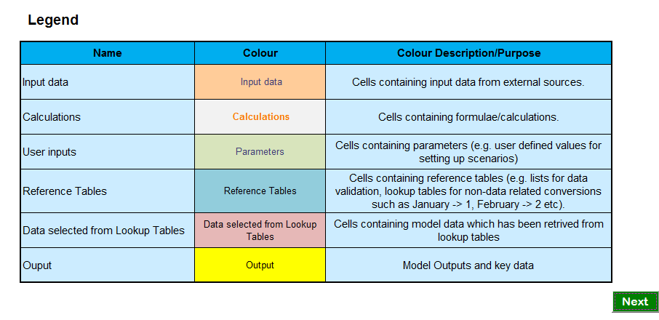

* + - “Model Structure”
  + Then use the standard Excel arrow buttons along the bottom of the screen:



to open the “Copyright” tab (extreme tab to the right): read this.

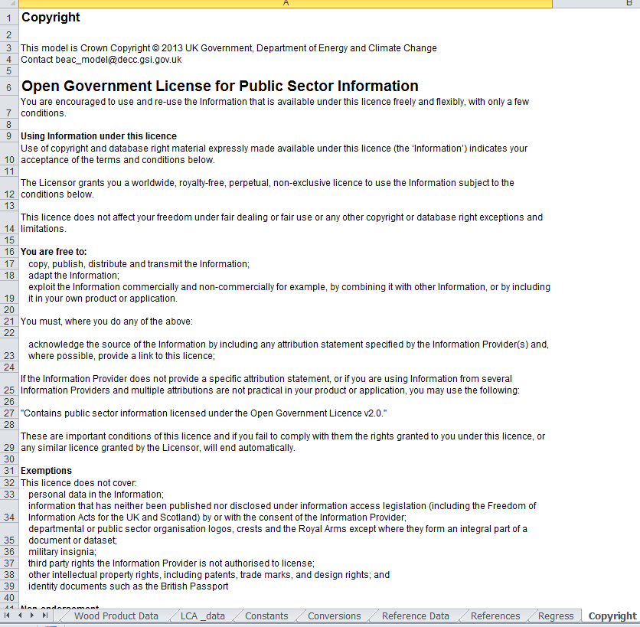

* + Now scroll back towards the left-most tabs and open the “Calculations” tab. This shows a diagram of how the scenario and the counterfactual are calculated and compared. Below the diagram are the calculations themselves. Do not bother with these yet.

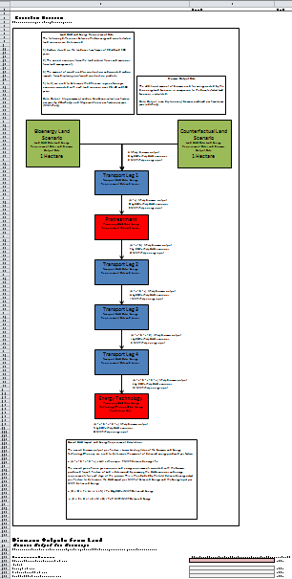

* + Then open the “Results_Biopathways” tab.
  + Press the “Select Scenario” button at the top left of the screen.
  + This will open up a popup menu:

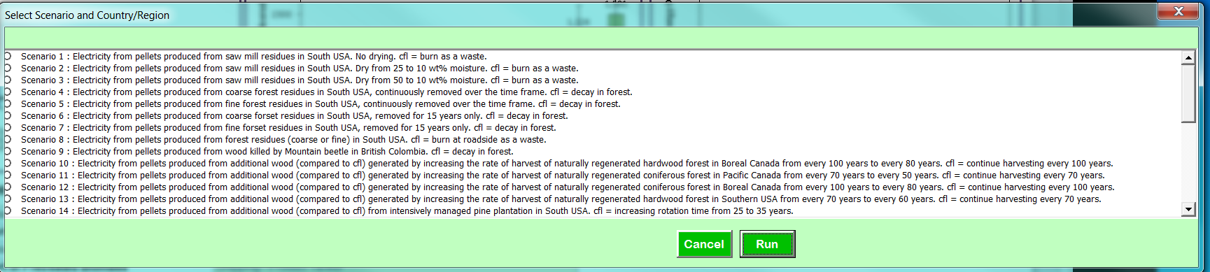

* + Select the top radio button for Scenario 1 (“*Electricity from pellets produced from saw mill residues in South USA. No drying. cfl = burn as a waste*.”)
  + Click the green “Run” button.
  + The popup will disappear and the results will be calculated.

1. You are now looking at the results for scenario 1 (this image is from model version BEAC1, your copy may be slightly different):

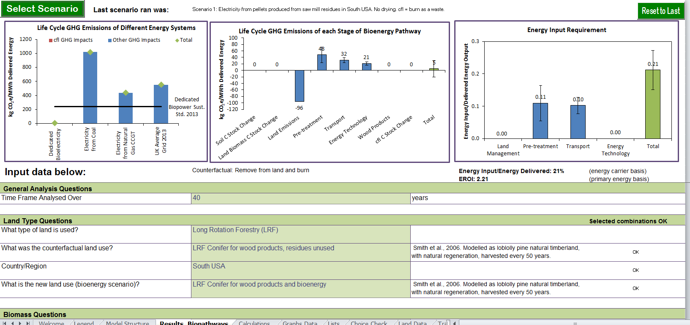

* + Now read section “Results – Woody Residues” of the full report (page 55 onwards).
  + Scroll down the page to examine the input parameters set up for Scenario 1 (in the cells coloured light green)

1. Read the “Discussion and Conclusion” of the full report.
2. Now select another Scenario from the drop-down menu in the middle of the sheet “Results_Biopathways” and read the corresponding part of the Results section of the main report.
3. Explore two more from each of “Woody Residues” and “Roundwood and Energy Crops”,
4. Now select scenario 30 and experiment with changing the input numbers on the sheet “Results_Biopathways”.
   * Start by changing the dropdown for “Time Frame Analysed Over” from 40 years to 20 years by clicking in the light-green coloured box with a “40” in it, in the middle of the top row of data.
   * Explore the implications in the results, and make sure that you understand why the figures change in the way that they do.
   * Repeat for other input parameters (which are all in shaded green boxes).
5. The last-but-one tab on the right is called “Regress”. It runs all the scenarios automatically.
   * It is a good idea to run this before and after you make any changes at all.
   * It will show you which scenarios are affected by any change you make.
   * More important, it will tell you if you have accidentally made any changes you didn’t mean to.
   * Remember that you can always download a fresh copy of the model if you want a clean copy. This is easier than trying to find all the changes you made and un-doing them.

#### Contact

Some limited support from DECC is available, when other work permits, by contacting [BEAC_model@decc.gsi.gov.uk](mailto:beac_model@decc.gsi.gov.uk)

#### References

<https://www.gov.uk/government/publications/life-cycle-impacts-of-biomass-electricity-in-2020>

<https://www.gov.uk/government/uploads/system/uploads/attachment_data/file/332946/life_cycle_impacts_of_biomass_electricity_in_2020.pdf>

<https://www.gov.uk/government/uploads/system/uploads/attachment_data/file/332948/beac_1.xlsm>